Name of the Student: G. Manasa | Academic Year: 2024 – 2028
Student Registration Number: 241U1R3007 | Year & Term: II & I
Study Level: UG | Class & Section: CSE – DS
Name of the Course: Java Programming | Name of the Instructor: Dr. A. Rajeshwar
Name of the Assessment: Lab Report - 2 | Date of Submission: 04-11-2025

- Write a Java program to demonstrate Objects and Classes.
Input:
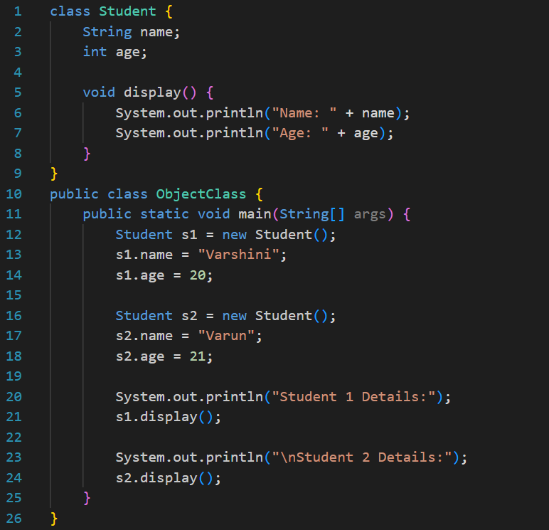
Output:
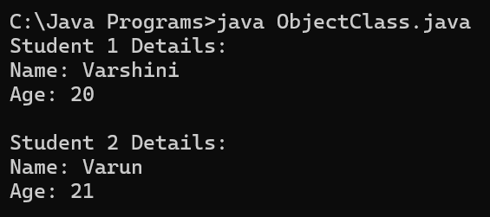
- Write a Java Program to pass the arguments from derived class to base class using super class.
Input:
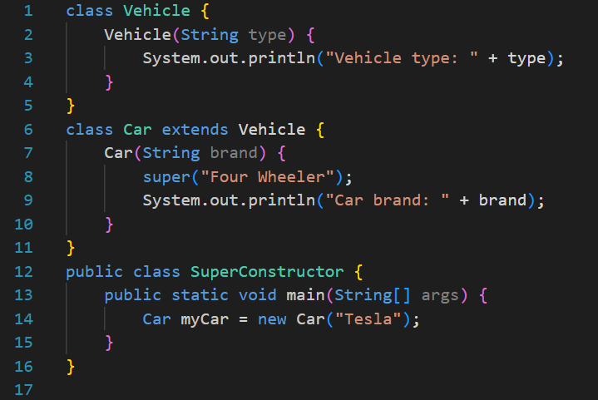
Output:
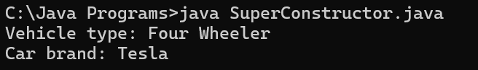
- Write a Java program to create object using constructor without arguments.
Input:
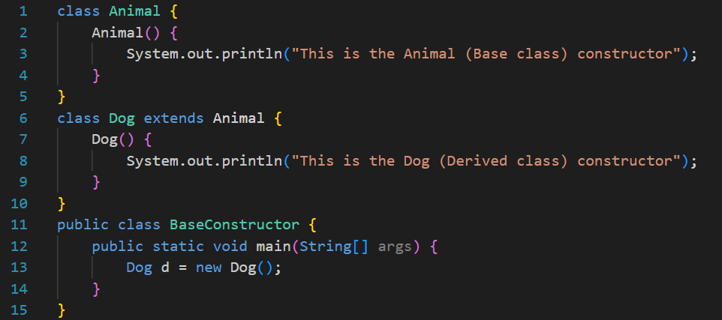
Output:
